Report on International Women’s Day Celebration
Marked annually on March 8th International Women’s Day is one of the most important days of the year to celebrate women’s achievement, raise awareness and campaign for gender equality. The Legal and Social Services Committee (LSSC) under the constant motivation of Hon’ble Vice Chancellor Prof. Dr. V.C. Vivekanandan and guidance of Dr. Balwinder Kaur, Faculty Co-ordinator, LSSC, HNLU decided to commemorate International Women’s Day by a mix of on-field and off-field activities on the theme “Menstrual Health and Hygiene”.
A woman’s menstrual health is essential to her well-being. Yet in majority of cases it is compromised due to lack of awareness. Awareness generation among women about maintaining Menstrual Health and Hygiene is the need of the hour. Ensuring that women are aware of the best practices to be followed during menstruation helps them avoid serious health issues. The journey from using a cloth to sanitary napkins has been a long one and still the destination is yet to be reached. Therefore, this year the committee was engaged in spreading awareness among women about the best practices they should adopt during menstruation.
As a part of on field activity the committee had organised an awareness camp in Ruabandha Basti of Bhilai on Menstrual Health and Hygiene. The committee members, Ms. Vibhuti Deshmukh (10th Semester) and Ms. Akanksha Das (4th Semester) anchored the awareness camp on behalf of the committee. They interacted with the women present at the occasion and learnt about the difficulties they face during menstruation. It was followed by a discussion with them about the safe practices to be followed. The members further engaged themselves in distribution of Sanitary Napkins to all of them in order to raise awareness for using the same. With this campaign the aim of the committee was to reach out to women and help them realise the importance of maintaining proper menstrual hygiene.
Below are the glimpses from the awareness campaign: -
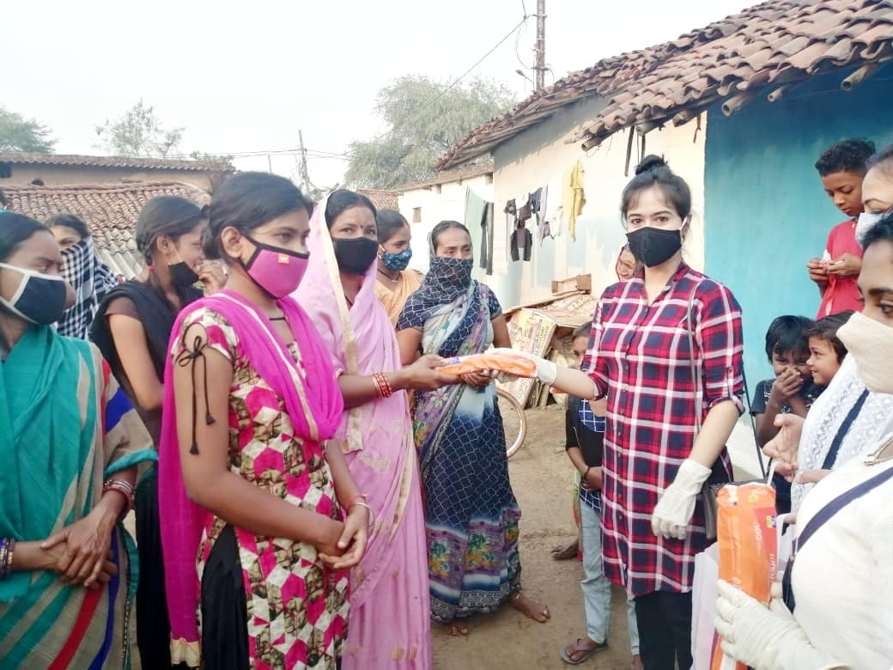
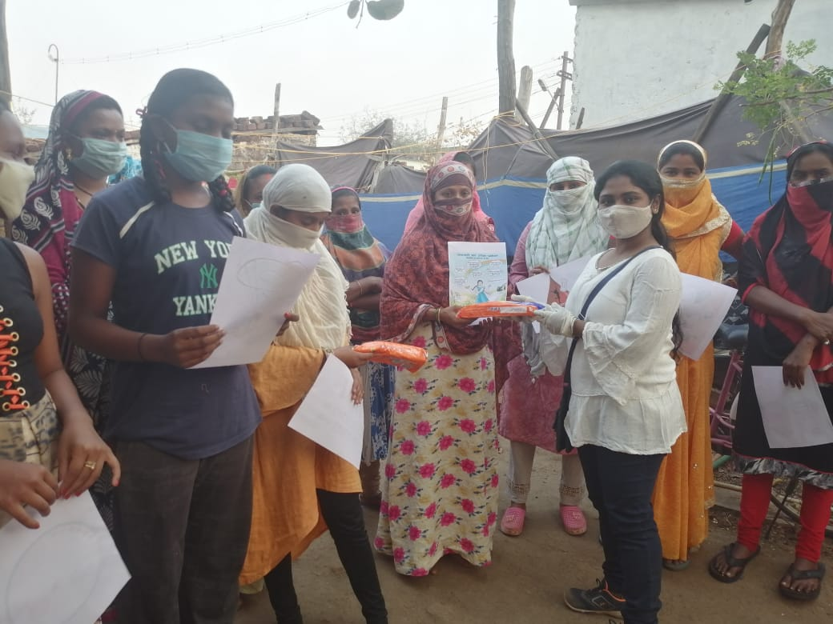
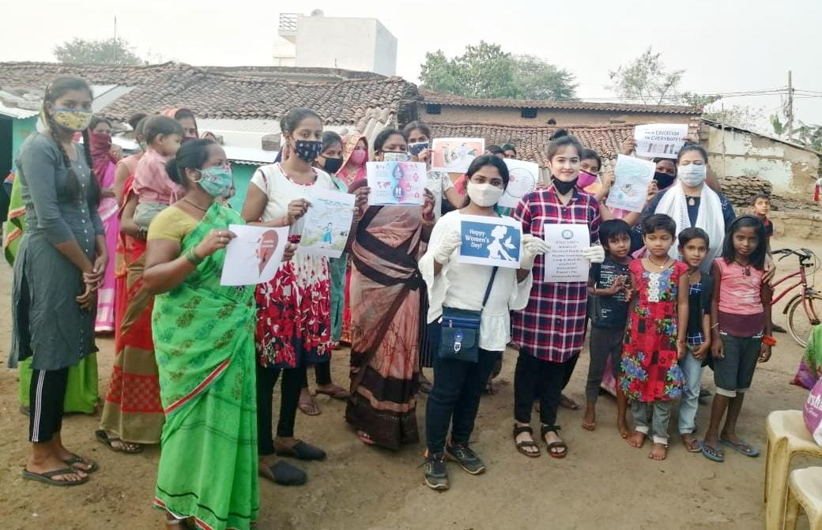
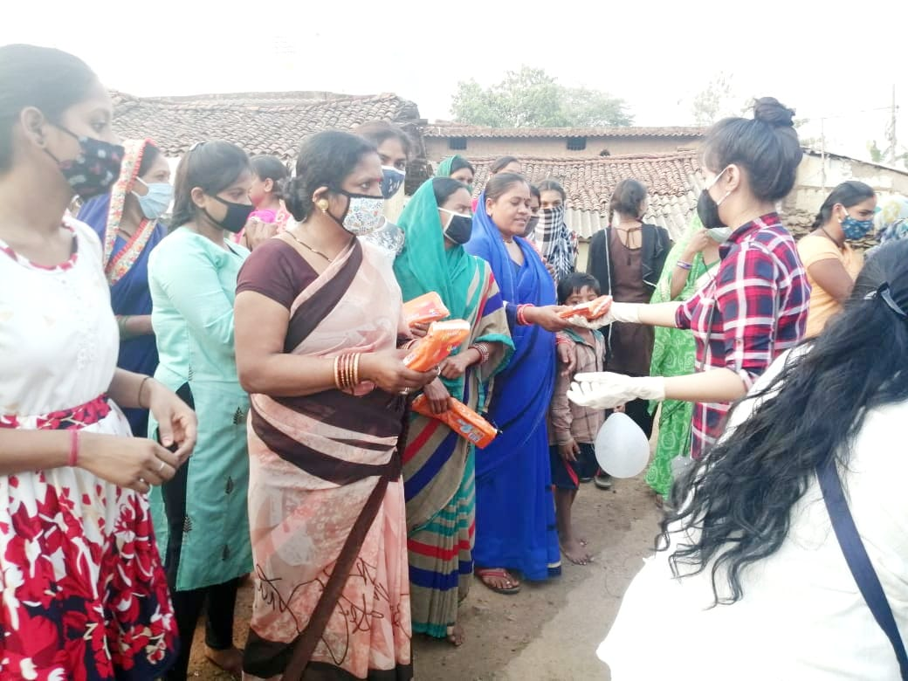
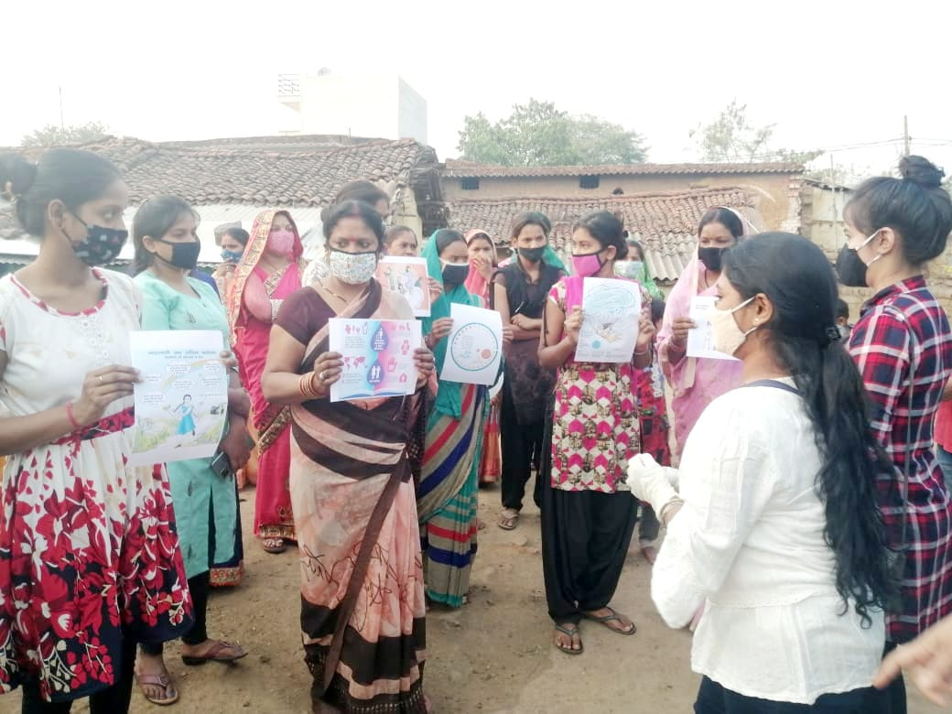
As a part of off field activity the committee had invited videos and posters from the students of the University on International Women’s Day.
Following is a poster from Sushmita Mandal of Semester IV: -
In this poster she has depicted the various roles that a female plays throughout her lifetime and gives out the message of “Respect Women”.
Next up is a poster from Supriya Bhatpahari from Semester IV: -
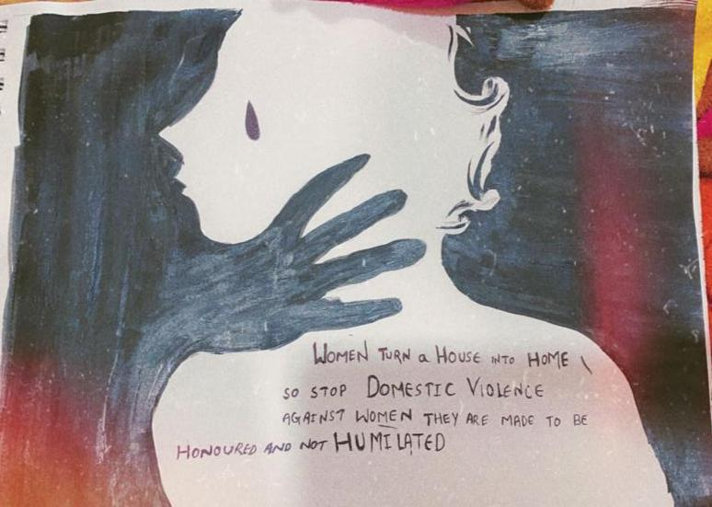
In this poster she talks about “Domestic Violence” and gives out the message on why is it necessary to put an end to it.
Next we have Varshunn Bhan from Semester IV: -
In this video she has depicted the best practices to be followed during menstruation.
Further we have Nandini Tandon from Semester IV: -
In this video she gives a detailed account of what a woman should do at the time of menstruation.
Up next we have Akanksha Das from Semester IV: -
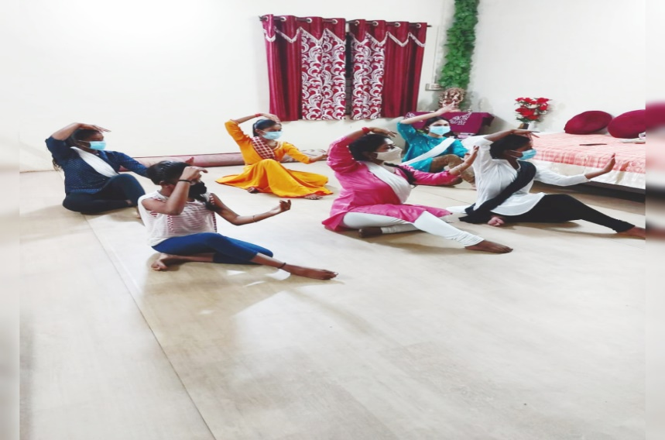
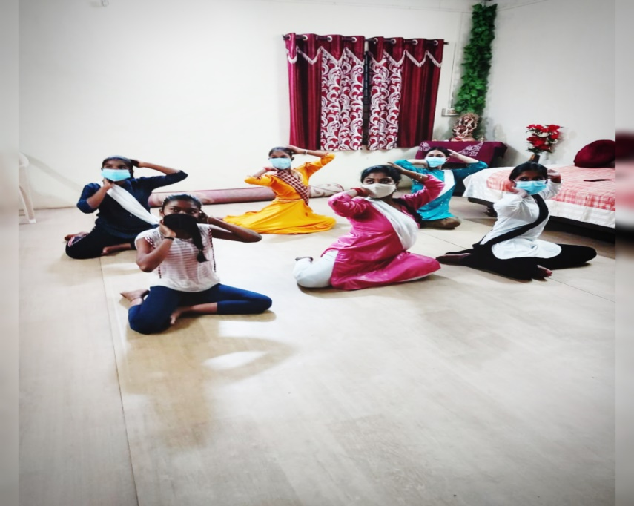
She is a Kathak Dancer and says,
“Indian classical dance "Kathak" is an age old dance form of Uttar Pradesh. In this dance form is famous for its swift body movements, spins, and expressions.
Imparting knowledge of ancient mythological stories as well as some other important aspects like realisation of the supreme power and self-exploration is the motive of Kathak.
Dance also provides a medium to celebrate the diversity of Indian society. Making these adolescent girls aware of the various body postures and human emotions (as we use in expressions) along with the cultural legacy makes me feel delighted and proud of Indian culture.”
The LSSC, HNLU stands in solidarity with all the women out there facing challenges and shall endeavour to extend all the possible help to empower them.

