INTERNATIONAL SYMPOSIUM
PEACE WITH NATURE:
LAWS FOR ECOLOGICAL RESILIENCE
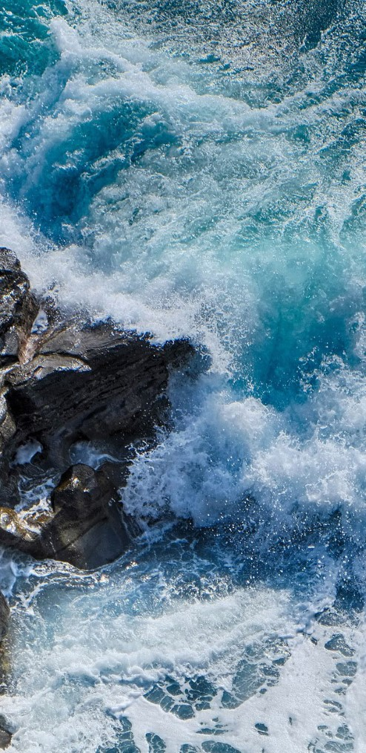
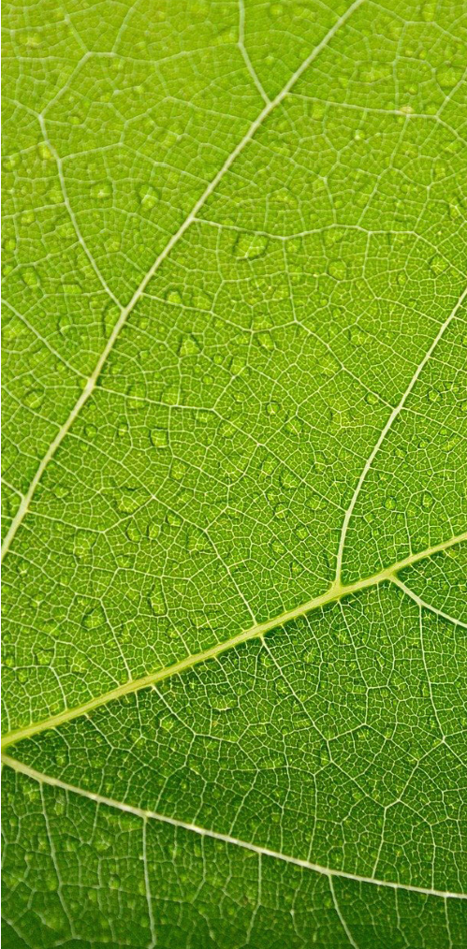
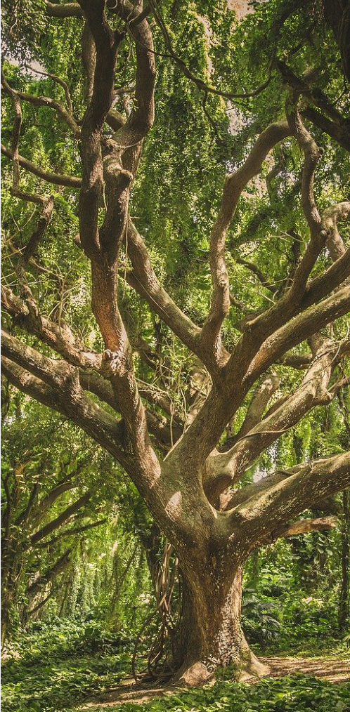
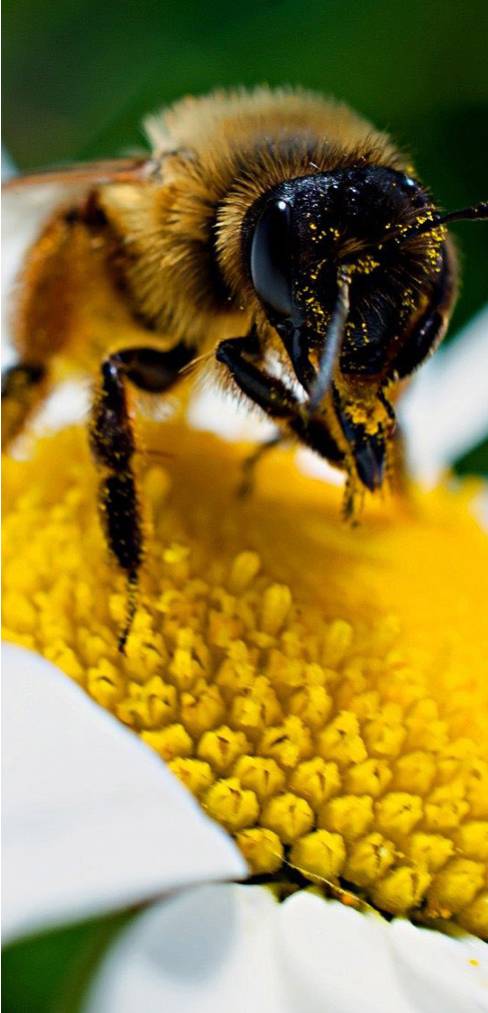
2-3 SEPTEMBER 2021
We will have Peace on Earth when we have Peace
with
the Earth.
https://www.unep.org/resources/making-peace-nature
MUCEM, MARSEILLE, FRANCE
Possibility of participating in the conference in person by invitation or in distance via streaming.
Free registration required.
All information on the website: https://peace-nature.sciencesconf.org/
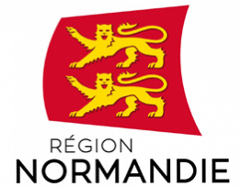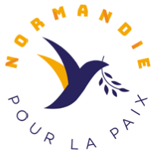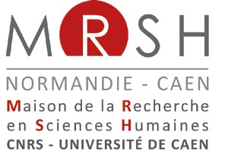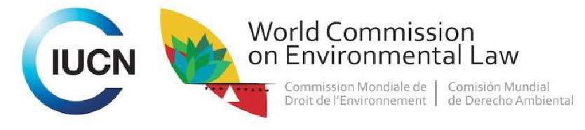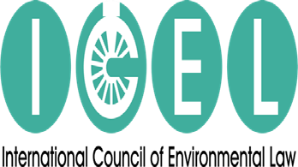

2 SEPTEMBER 2021, THURSDAY
- 8:30 - Participants assemble at MUCEM
- 9:00 - Welcomes - Moderator: Reinhard KRAPP (Germany)
> Prof. Nicholas A. ROBINSON, Executive Governor, ICEL
> François Xavier PRIOLLAUD, Région Normandie (by ZOOM video)
> Pascal BULÉON - MRSH
> Emilie GAILLARD, Normandy Chair for Peace
> Grethel AGUILAR, Associate Director-General IUCN
- 9:30 - Ecological Law – Ethical foundations
Moderator : Prof. Emilie Gaillard
> Prof. Klaus BOSSELMANN, Ecological Law & Governance Association (by ZOOM video)
> Katy GWIAZDON, Ethics Specialist Group, IUCN WCEL
> Patrick BLANDIN, IUCN Comité français l’UICN
> Prof. Jochen SOHNLE et Prof. Christophe BOURIAU,, University of Nancy, Normandy Chair for Peace
- 10:30 – Coffee/Tea break
- 11:00 – Artificial Intelligence: Providing Nature with Autonomy and Stewardship Moderator : Prof. Victor TAFUR
> Prof. David FREESTONE (Video talk): Deploying AI: The Sargasso Sea Commissions
> Prof. Andrea LEITER: Establishing Agency for Nature: The Sovereign Nature Initiative
> Rutger van ZUIDAM (with a video component): Creating collaborative collectives for human intelligence - common ground for grass roots regenerative AI

- 11:45 – Legal Indicators – Measuring How we Observe Environmental Duties
- Moderator : Pascal BULEON (France)
> Prof. Michel PRIEUR (By ZOOM vidéo)
> Christophe BASTIN, Normandy Chair for Peace.
> Umair SALEEM, Lahore’s Judicial Commissions, Pakistan
- 12:15 - Duties for the Rights of Future Generations: The Promise of the International Court of Justice Advisory Opinion
Moderator : Laura DUARTE, Normandie Chair for eace
> Nicole Ann PONCE, Solomon YEO, WYCJ (By ZOOM vidéo)
> Alyn WARE, Rob Van RIET (Par ZOOM vidéo) and Samira BEN ALI, Olivia RICHARD (Normandy Chair for Peace)
- 12h45 – Luncheon Break
- 2:00 pm – From Transitional Justice to Environmental Peacebuilding: Broadening the Legal Framework
Moderator : Prof. Victor TAFUR
> Laetitia BRACONNIER, PhD student University of Paris Nanterre and National University of Colombia,Normandy Chair for Peace(via ZOOM video)
> Luis Miguel GUTIERREZ, University of Poitiers (CECOJI), Normandy Chair for Peace
> Eduardo FRULEUX, Normandie Chair for Peace
> Camillo NIÑO, Indegenous Arhuaco (invited - via ZOOM video)
- 3:00 pm – Sanctuarisation of Forest
Moderator : Prof. Chikosa BANDA (Malawi)
> Gert Peter BRUCH, Planet Amazon, Normandy Chair for Peace
> Apollinaire OUSSOU LIO, Environmental protector Bénin
> Mindahi BASTIDA, Otomi indigenous representant
> Laura PAQUEMAR, Normandy Chair for Peace
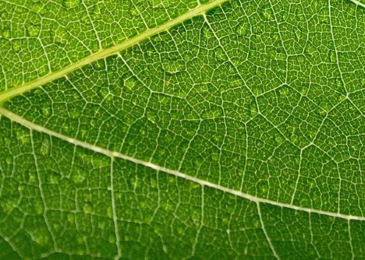
- 4:00 pm – Ensuring Food Sovereignty and Protecting Biodiversity through the UN Declaration on the Rights of Peasants
Moderator : Gustavo ALONIS, Mexican Center for Environmental Law
> Prof. Smita NARULA, Elisabeth Haub School of Law School at Pace University (via ZOOM video)
Genevieve SAVIGNY, Confederation Paysanne and La Via Compesina (France) Via ZOOM video)
> Cassandra JURENCI & Nick SIOUFAS, Elisabeth Haub School of Law School at Pace University (via ZOOM video
- 4:45 pm - Tea/coffee break
- 5:00 pm – World Premier Performance –MI Music Caring for The Earth –
  - Moderator: Prof. Nicholas A. ROBINSON
  - Prof. Koh Kheng Lian (Video presentations)
  - “Voice of the Sea” composed ad conducted by Amos CHIYA, ICEL Representative for Music & Culture
- 5:40 pm - 50 years of Crafting Environmental Law: A Good Story
> H. E. Donald KANIARU, ICEL Representative in Nairobi and Prof. Nilufer ORAL (Turkey), Director NUS Center for International Law & UN ILC Member and Prof. Victor Tafur
Commemorating the Jurists Behind the Intergenerational accomplishments of the 1972 Stockholm Declaration on the Human Environment, 1982 UN Charter for Nature, 1992 Rio Declaration on Environment & Development and 2002 Johannesburg Declaration on Sustainable Development, and recalling The Legacy of Dr. Wolfgang E. Burhenne.
- 6:30 pm – Adjourn for the day

3 SEPTEMBER 2021, FRIDAY
- 8:30 - Participants assemble at MUCEM
- 9:00 – Renewing the Foundations for Rights in Harmony With Nature / Right of Future Generations
Moderator : Prof. Victor TAFUR
> Émilie GAILLARD, General coordinator Normandie Chair for Peace: Towards a transgenerational approach of Human Rights and Duties
> Corinne LEPAGE, Attorney : Universal Declaration of the Rights and Duties of Humankind > Prof. James R. MAY: Actualizing the Rights of Nature (via ZOOM video)
- 9:30 – Good Stories: Harmonizing Law With Earth’s Natural Systems
- Moderator : Prof Abad Montserrat (Spain)
> Durwood Zaelke : Uniting to Conserve the Stratospheric Ozone (IGSD)
> Andrew David RAINE, UN Environment Programme - Montevideo Environmental Law Programme V: A Decade of Action on Environmental Rule of Law
> Sasha KOOOSHIMA (FAO): One World/One Water

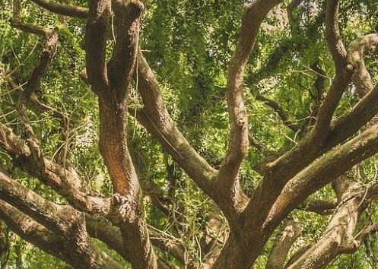
> 10:30 – Why Are States Timid to Acknowledge “Rights”?
- 11:00 – The Environmental Rule of Law
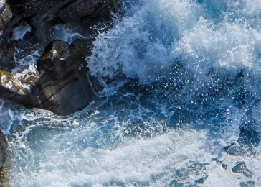
Moderator : Prof. Nicholas A. Robinson
> Justice Antonio Herman BENJAMIN (Brazil), IUCN WCEL Chair
> Gustavo ALANIS, Mexican Center for Environmental Law
> Arnold KREILHUBER, UN Environment Programme (by ZOOM video)
> Scott FULTON, Environmental Law Institute
Prof. Nicholas BRYNER, Deputy Chair, IUCN World Commission on Environmental Law
Moderator: Nicholas A. ROBINSON
> Prof. Yann AGUILA & Marie-Cecile DE BELLIS : What does a Martian See In Us ?
- 11:00 – Coffee/tea break
- 11:15 – The Environmental Rule of Law
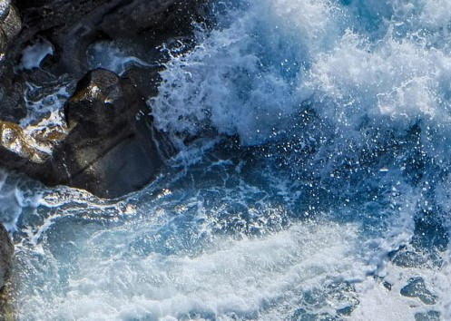
Moderator : Prof. Nicholas A. ROBINSON
> Justice Antonio Herman BENJAMIN (Brazil), IUCN WCEL Chair
> Gustavo ALANIS, Mexican Center for Environmental Law
> Arnold KREILHUBER, UN Environment Programme (by ZOOM video)
> Scott FULTON, Environmental Law Institute
Prof. Nicholas BRYNER, Deputy Chair, IUCN World Commission on Environmental Law
Ayman CHERKAOUI, Manager for Senior Strategic Development, Mohammed VI Foundation for Environmental Protection)

- 1:00 – Luncheon Break
- 2:00 pm - IUCN WCC – Towards IUCN Addressing Earth “Existential” Crises
Moderator: Nicholas A. ROBINSON
> Justice Michael WILSON: A Climate Crisis Commission & Motion 003
> Prof. Elisa SCOTTI – Global Pandemic Network (GPN) - Zoonoses & COVID 19
> Christopher SUDOL (via ZOOM video), et Prof. David FORMAN : Indigenous Rights: Renouncing the Doctrine of Discovery
> Allison WOOD & Prof. Richard L. OTTINGER (by ZOOM video): The Energy Crisis & IUCN’s Programme

PROGRAMME
Program subject to modifications due to the Pandemic
- 2:45 pm – Commemoration: In Memoriam, the Defenders of Nature
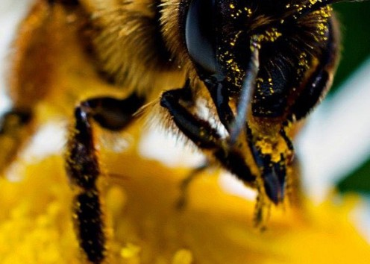
> Antonio BENJAMIN, Patricia MBOTE (by ZOOM vidéo), Andy RAINE, Antonio OPOSA, Smita NARULA (with a video component from the Elisabeth Haub Award Ceremony, at Pace University, New York), honoring ENVIRONMENTAL DEFENDERS, in memoriam
- 3:15 pm - « Toward Our Future »
Moderator : Justice Antonio Herman BENJAMIN (Brazil)
> Prof. Dr. Christina VOIGT, Chair candidate, IUCN WCEL
- 3:45 pm – Ceremony closes – “Peace with the Earth”
Moderator : Prof. Emilie GAILLARD, Normandy Chair for Peace
> Antonio OPOSA, Chaire Normandie pour la Paix
[4:15 Participants depart for Convention Center and 17:00 (5:00 pm) opening ceremony of the IUCN WCC]
